In class Examples for Relational Algebra: Tuesday 9/23/20  
Select supplier name and number

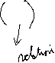

Select supplier name, supplier number, and quantity they have shipped where the quantity is greater than 100

TIMES



JOIN

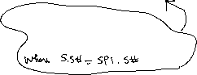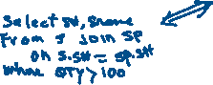

LEFT JOIN



RIGHT JOIN



Natural Join



t part number and part name for those suppliers from London are supplying



TIMES

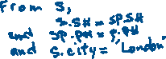

JOIN

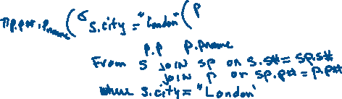

LEFT JOIN



RIGHT JOIN



Natural Join

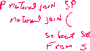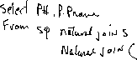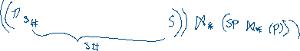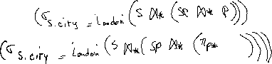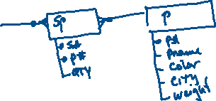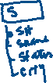

In-class assignment (Relational Algebra):

List all suppliers that are supplying Red parts in quantity great than 200

TIMES

JOIN

LEFT JOIN

RIGHT JOIN

Natural Join